Part A. Speak about the following questions in small groups.

- Do you like living in Istanbul?
- Which other nationalities live in Istanbul?
- Are people friendly to foreign communities?

Part B. Skim through the text. Which of the following would be the best title?

- Why Study in London?
- Characteristics of Londoners
- London: The World in One City


1 New York and Toronto may think they are more cosmopolitan, but London in the 21st century is certainly the most diverse city ever. This is one of the reasons why it was chosen to host the 2012 Olympic Games. More than 300 languages are spoken by the people of London, and it has 50 nationalities with populations of more than 10,000.

2 Why is this? Firstly, London is a place of business. Londoners have the fewest bank holidays in Europe and work the longest hours. People come for jobs and money. But that is not why they stay. Language is one reason. Fluency in English is a great gift for their children. Another surprising reason is the character of the London people. They are not as friendly as some other nationalities. But this has advantages; people leave you alone, and you are free to live your own life. Finally, the most delicious reason is food. You can have dinner in more than 70 different nationalities of restaurant any night of the week. Londoners’ enthusiasm for foreign food creates thousands of jobs for new communities.

Leo Benedictus spent months interviewing the immigrant communities that give the city of London its vitality and, more importantly, its food!

3 All Londoners, old and new, have the same principles. They work hard, love their children, and move out of the city center as soon as they can afford it!

Posh Daddy from Nigeria
4 Posh Daddy is the manager of the Big Choice Barber’s on Peckham High Street. It is a West Indian and African hairdresser’s. These two black communities haven’t always got on well together. ‘When I first came here, we just wanted to be accepted by the West Indian community, but they weren’t very friendly,’ he says, ‘Now it is getting better. These days most of my West Indian brothers in the barber’s like eating African food like me, pepper soup and kuku paka, which is chicken with coconut – very hot and spicy.’

Staff in the kitchen of the Asadal
5 ‘This restaurant was a little bit of Korea brought into a very English town,’ says Young-il Park, the manager of the Asadal restaurant in New Malden. The Asadal is famous for its kimchi – salty spicy chili peppers and vegetables. Young-il’s father opened the Asadal in 1991 – the first Korean restaurant in the town. Young-il was the only Korean in his school. ‘The thing I noticed most was that people stared,’ he says, ‘Now you see a lot of Koreans here.’

The staff in the Yaşar Halim Bakery
6 Yaşar Halim, a Turkish grocer’s and baker’s, is known all over London. It was opened in Green Lane in 1981 by Mr. Halim, a Turkish Cypriot. At that time, no one was selling food from his homeland. Now the shop is famous for its baklava, a sweet cake made with nuts and honey. The shop is very busy, and the staff working there – both Turkish and Greek Cypriots – look like they’re having a great time together. In their homeland of Cyprus, there are still problems between the two communities. But in this area of London, they live together as good neighbors.

Portuguese football fans in the FC Porto Fan Club in Stockwell
7 ‘Football is a passion for us,’ says José Antonio Costa, the president of the Porto Fan Club which meets in Stockwell. ‘Many people come for friendship – you know, in a foreign country, you feel more comfortable with your own people.’

8 Eric Santos, the owner of Santos’s café near the club, says, ‘People come for my wife’s bacalhau – salted cod, made with potatoes and onions. Delicious!’ There is quite a big Portuguese-speaking community here, from Portugal, Brazil and Madeira, but they do not always stick together. ‘Everyone looks after their own interests.’ The Portuguese and the Madeirans, in particular, are very separate groups in London, because Madeira wants independence from Portugal.

Part C. Match the following paragraphs with the relevant pictures.
- 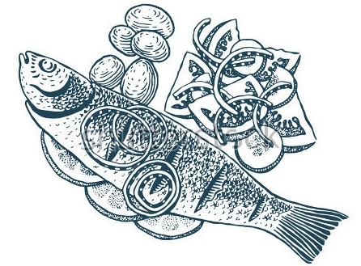 | - 
- 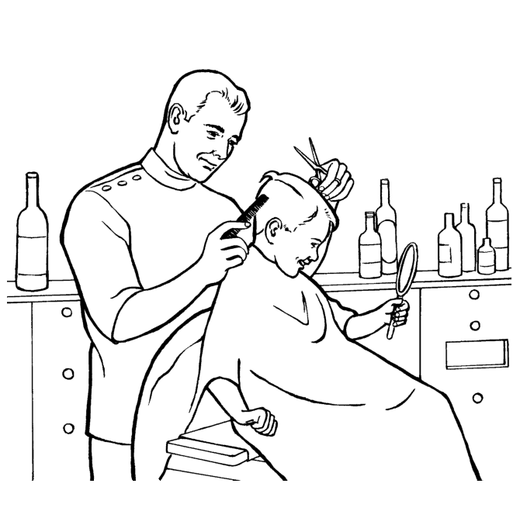 | d)
- Paragraph 4 _____
- Paragraph 5 _____
- Paragraph 6 _____
- Paragraph 8 _____

Part D. Circle the correct answer.

- Which of the following is NOT a reason why London is cosmopolitan?
- It was chosen to the 2012 Olympic Games.
- Kids can learn English there.
- You can find food from all over the world there.
- There are lots of job opportunities.

- In Paragraphs 1 and 2, the writer used different words to describe the people living in London. Which of the following is NOT one of them?
- Londoners c. the London people
- the people of London d. the people in London

- Which of the following is FALSE according to Paragraph 4?
- West Indian people didn’t like Africans at first.
- Now Africans and West Indians are getting on better.
- Kuku paka is Indian food with chicken and coconut.
- Posh Daddy had difficulty when he first came to London.

- According to the text, some communities do not get on well with each other. Which of the following pairs is NOT one of them?
- West Indians and Africans
- Koreans and the Chinese
- The Turkish and Greek Cypriots
- The Portuguese and the Madeirans

- Yaşar Halim’s shop was special in 1981 because…
- …there weren’t any other shops selling food from other countries.
- …it was very busy and popular.
- …it was the first grocery shop in Green Lane.
- …customers were having a good time there.

- “Enthusiasm” in Paragraph 2 is closest in meaning to _________.
- hate b. ideas c. interest d. energy

- “Afford” in Paragraph 3 is closest in meaning to _________.
- have enough money for c. decide to do
- change d. search

- “Staff” in Paragraph 6 is closest in meaning to _________.
- boss b. workers c. equipment d. customers

- “Independence” in Paragraph 8 is closest in meaning to _________.
- love b. help c. support d. freedom

Part E. What do the following refer to in the text? They are underlined in the text.
1. “it” in Par. 1: ________________________________________
2. “It” in Par. 4: ________________________________________
3. “they” in Par. 4: ________________________________________
4. “they” in Par. 6: ________________________________________
5. “they” in Par. 8: ________________________________________

Part F
- Fill in the following chart first. Then, compare it with your partner.
Advantages of living in a cosmopolitan city | Disadvantages of living in a cosmopolitan city

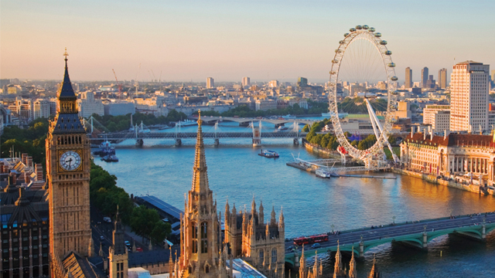
- Speak about the following questions with your partner.
- Would you like to move to a more cosmopolitan city like London? Why?
- Imagine you have moved to London and you want to open a shop. What kind of shop would you like to open?

